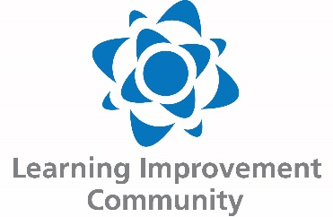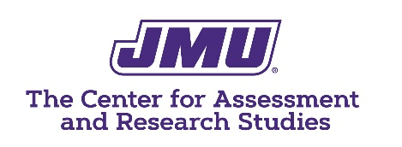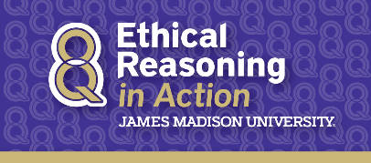

Learning Improvement (Resources)
The Basics
A Simple Model for Learning Improvement: Weigh Pig, Feed Pig, Weigh Pig
https://www.learningoutcomesassessment.org/wp-content/uploads/2019/02/OccasionalPaper23.pdf
Video related to “Pig” paper
https://www.youtube.com/watch?v=5ZRbynb5QBk
Special issued in Research and Practice in Assessment
http://www.rpajournal.com/download-full-issue-pdf-12/

The Learning Improvement Community
The Learning Improvement Community (LIC) website has stories of learning improvement, resources, and a way to submit a story to be published on the site
https://www.learning-improvement.org/
During our live session, we'll read and discuss a learning improvement story, Improving Undergraduate Writing in an Interdisciplinary Program. Links to the story
https://www.learning-improvement.org/story-pacificislandsstudies-uhm
Alternative site (Google Doc)
https://docs.google.com/document/d/1ULdmzMabnwkT0jd4az8QKetjP2aEF513THKvNuMP0ho/edit?usp=sharing
Contact the LIC for information and opportunities to participate:
email hello@learning-improvement.org

Ethical Reasoning in Action and Learning Improvement

Ethical Reasoning in Action
www.jmu.edu/ethicalreasoning

Multi-media ethical reasoning assessment report
https://spark.adobe.com/page/qUa3sKSo4gpZu/

Dissertation on ethical reasoning and learning improvement
https://commons.lib.jmu.edu/diss201019/153/

