Academic Program Assessment Calendar
FALL SEMESTER |  | SPRING SEMESTER
August |  | January
Collect program data results from Summer  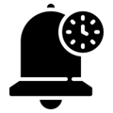  Collect action plan data results from Summer  Remind faculty to assess program and/or Gen Ed outcomes for Fall  Remind faculty to assess action plan items for Fall |  | Remind faculty to assess program and/or Gen Ed outcomes for Spring  Remind faculty to assess action plan items for Spring
September |  | February
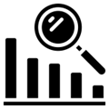  Organize and analyze data from previous academic year for program assessment  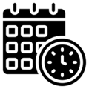  Organize and analyze data from previous academic year for action plan assessment  Schedule program meeting |  | Organize and analyze report feedback from CTLA  Organize and analyze Gen Ed data from CTLA  Schedule program meeting
October |  | March
Discuss results, design action plans, and build assessment report at program meeting |  | Discuss report feedback and Gen Ed data and revise program assessment plan and/or action plans at program meeting
November |  | April
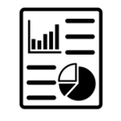  Submit report by Nov. 15 - Follow reporting schedule |  | Remind faculty to assess program and/or Gen Ed outcomes for Summer  Remind faculty to assess action plan items for Summer
December |  | May
Collect program data results from Fall  Collect action plan data results from Fall |  | Collect program data results from Spring  Collect action plan data results from Spring
 |  | June & July
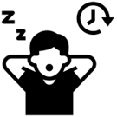
No coordinator tasks
2300 S. Washington St., IUK Library, KA 120, Kokomo, IN 46902
kokomo.iu.edu/ctla | ctla@iuk.edu

